Semi-Supervised Machine Learning — Complete Detailed Notes

1. Introduction
Machine Learning algorithms generally learn from data in one of three ways:
- Supervised Learning — uses labeled data.
- Unsupervised Learning — uses unlabeled data.
- Semi-Supervised Learning — uses a combination of a small amount of labeled data and a large amount of unlabeled data.
Semi-Supervised Learning (SSL) is particularly useful when obtaining labels is expensive, time-consuming, or requires human expertise, while collecting raw/unlabeled data is relatively easy.

Simple Example
Suppose we want to classify medical X-ray images as:
- 0 → Healthy
- 1 → Disease
We have:
- 1,000 labeled X-rays
- 100,000 unlabeled X-rays
Training a supervised model using only the 1,000 labeled examples wastes potentially useful information contained in the 100,000 unlabeled examples.
Semi-supervised learning attempts to use both datasets:
Dataset
|
+------------+------------+
| |
Labeled Data Unlabeled Data
(small) (large)
| |
+------------+------------+
|
SSL Algorithm
|
Trained Model
|
Prediction

2. Definition

Definition
Semi-Supervised Machine Learning is a machine learning paradigm in which a model learns from a combination of a relatively small labeled dataset and a relatively large unlabeled dataset.

3. Why Semi-Supervised Learning?
The central problem is:
Labeled data is expensive, but unlabeled data is cheap.
For example:
Application | Labeled Data | Unlabeled Data
Medical diagnosis | Requires doctors | Many medical images
Speech recognition | Requires transcription | Huge audio collections
Image classification | Requires manual annotation | Millions of images
Spam detection | Requires labeling emails | Huge email collection
Web page classification | Requires human labeling | Billions of web pages
Autonomous driving | Requires annotation | Massive sensor/video data
Consider image classification.
Getting:
Image → Cat
requires a human to inspect the image.
But collecting:
Image
Image
Image
Image
...
is relatively easy.
Therefore, SSL tries to extract information from the unlabeled examples.

4. Supervised vs Unsupervised vs Semi-Supervised Learning

Supervised Learning
Uses only labeled data.
Example:
Input Label
------------------
Image 1 Cat
Image 2 Dog
Image 3 Cat
Image 4 Dog
Algorithms:
- Linear Regression
- Logistic Regression
- Decision Trees
- Random Forest
- SVM
- Neural Networks

Unsupervised Learning
Uses only unlabeled data.
Example:
Image 1
Image 2
Image 3
Image 4
The model attempts to discover structure.
Algorithms:
- K-Means
- DBSCAN
- PCA
- Autoencoders
- Gaussian Mixture Models

Semi-Supervised Learning
Uses both.
Example:
Labeled:
Image 1 → Cat
Image 2 → Dog
Image 3 → Cat
Unlabeled:
Image 4
Image 5
Image 6
Image 7
...
The unlabeled examples can help improve the learned decision boundary.

5. Intuition Behind Semi-Supervised Learning
The key intuition is:
Unlabeled data tells us something about the structure/distribution of the data, even though it doesn’t directly tell us the labels.
Suppose we have two classes:
Class A: ● ● ● ●
Class B: × × × ×
The labeled data may be small:
● ● ×
●
×
But after observing many unlabeled points:
● ● ● ● ● × × × ×
● ● ● ● ● × × × ×
● ● ● ● × × × ×
we can understand that the data naturally forms two groups.
The unlabeled data therefore helps us determine where a good decision boundary should be.

6. Main Assumptions in Semi-Supervised Learning
SSL works because we make assumptions about the relationship between the input data and labels.
The most important assumptions are:
- Smoothness assumption
- Cluster assumption
- Manifold assumption
- Low-density assumption

7. Smoothness Assumption
The smoothness assumption states approximately:
If two data points are close to each other in the input space, they are likely to have similar labels.

Example
If two images are almost identical:
Image A → Cat
Image B → ?
It is reasonable to expect:
Image B → Cat

8. Cluster Assumption
The cluster assumption says:
Data points tend to form clusters, and points within the same cluster are likely to belong to the same class.
Imagine:
● ● ●
● ● ● ●
● ●
× ×
× × × ×
× ×
There are two clusters.
If a few points are labeled:
● = Class A
× = Class B
we can infer that other points in the corresponding clusters probably have the same labels.

Mathematical intuition
We want the decision boundary to avoid passing through high-density regions.
Instead:
Cluster A | boundary | Cluster B
rather than:
Cluster A
|
boundary
|
Cluster A

9. Low-Density Separation Assumption
A good decision boundary should preferably pass through regions where there are few data points.
Suppose:
● ● ● ●
● ● ● ●
|
| Decision boundary
|
× × × ×
× × × ×
The boundary lies in a low-density region.
This is generally better than:
● ● | × ×
● ● | × ×
● ● | × ×
where the boundary cuts through a dense region.

10. Manifold Assumption
High-dimensional data often lies approximately on a lower-dimensional structure called a manifold.
For example, an image may contain thousands or millions of pixel values:
[ x ^{100000} ]
but the meaningful variation in images may be controlled by only a much smaller number of factors.
For example:
- object orientation
- lighting
- size
- position
- shape
Thus:
[ ]
SSL can use unlabeled data to discover this underlying structure.

General Semi-Supervised Learning Objective
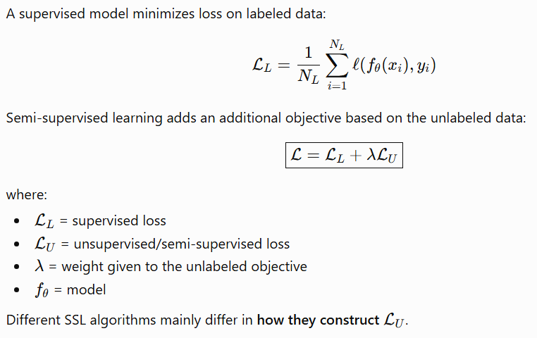

12. Types of Semi-Supervised Learning
Major approaches include:
- Self-training
- Pseudo-labeling
- Label Propagation
- Label Spreading
- Co-training
- Consistency Regularization
- Mean Teacher
- Virtual Adversarial Training

13. Self-Training
Self-training is one of the simplest SSL techniques.
Definition
Self-training is a semi-supervised learning technique in which a model is first trained on labeled data, then uses its own predictions to assign labels to unlabeled data.
The newly labeled examples are called pseudo-labeled examples.

Basic idea
- Train a model using labeled data.
- Predict labels for unlabeled data.
- Select predictions with high confidence.
- Treat those predictions as pseudo-labels.
- Add them to the labeled dataset.
- Retrain.
- Repeat.

Self-Training Example
Initially:
Labeled:
A → Cat
B → Dog
C → Cat
Unlabeled:
D
E
F
G
Train the model.
Predictions:
D → Cat 98%
E → Dog 95%
F → Cat 51%
G → Dog 99%
Use only confident predictions:
D → Cat 98%
E → Dog 95%
G → Dog 99%
Ignore:
F → Cat 51%
Now the training set becomes:
Original labeled data
+
D → Cat
E → Dog
G → Dog
Train again.

Pseudo-Labeling

Definition
Pseudo-labeling assigns model-generated labels to unlabeled examples and uses sufficiently confident predictions as additional training targets.
You can think of:
Pseudo-labeling as one of the most common ways to implement self-training.

17. Label Propagation

Label Propagation is a graph-based semi-supervised learning algorithm that propagates labels from labeled examples to nearby unlabeled examples.

Main idea
Represent each data point as a node in a graph.
Similar data points are connected with edges.
For example:
A
/ \
B---C
\ /
D
E---F
\ /
G
If:
A → Class 1
E → Class 2
the labels can propagate through the graph.

18. Mathematical Formulation of Label Propagation
Construct a graph:
G=(V,E)
where:
- (V) = data points
- (E) = relationships between data points
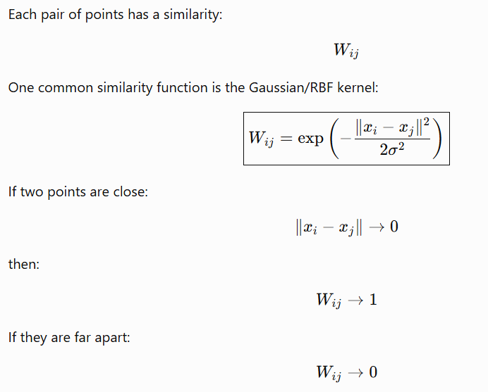
19. Graph Laplacian
Define the degree matrix:
Dii=∑jWij
Then:
L=D−W
where L is the graph Laplacian.
The graph-based smoothness objective is:
½ ∑i,j Wij ∥fi−fj∥²
This encourages strongly connected nodes to have similar predictions.

20. Label Spreading
Label spreading is another graph-based SSL technique.
It is similar to label propagation but generally uses a normalized graph structure and allows labels to be softened/regularized.
The intuition is:
Labeled point
↓
Nearby points
↓
More nearby points
↓
Label spreads through graph

21. Label Propagation vs Label Spreading
Feature | Label Propagation | Label Spreading
Graph-based | Yes | Yes
Uses unlabeled data | Yes | Yes
Label propagation | Strong | Yes
Regularization | Less | More
Label clamping | Stronger | Softer
Noise handling | Can be sensitive | Often more robust

32. Practical Semi-Supervised Learning Workflow
A typical workflow is:
Raw Dataset
|
Split the data
|
+---------+---------+
| |
Labeled Unlabeled
| |
+---------+---------+
|
Initial Model
|
Predict Unlabeled
|
Confidence Check
|
+---------+---------+
| |
Confident Uncertain
| |
Pseudo-label Ignore
|
+---------+
|
Retrain Model
|
Repeat
|
Evaluate

33. Important: Keep a Validation/Test Set Truly Labeled
One common mistake is to use the entire dataset in SSL.
The evaluation data should remain separate.
For example:
100,000 total examples
5,000 labeled training
90,000 unlabeled training
5,000 labeled test
The model must not use test labels during training.
Otherwise, evaluation becomes invalid.

48. Advantages of Semi-Supervised Learning

1. Reduces labeling cost
This is the biggest advantage.
Instead of labeling:
[ 1,000,000 ]
examples, we might label only:
[ 10,000 ]
and use the rest as unlabeled data.

2. Uses abundant unlabeled data
Many real-world applications naturally generate huge amounts of unlabeled data.

3. Can improve generalization
When SSL assumptions are appropriate, unlabeled data can help the model learn the underlying structure.

4. Useful when labels are expensive
Especially useful for:
- medical data
- scientific data
- legal documents
- satellite imagery
- industrial inspection

5. Can improve data efficiency
The model may achieve good performance using fewer labeled examples.

49. Disadvantages of Semi-Supervised Learning

1. Incorrect pseudo-labels
The model may produce wrong pseudo-labels.

2. Confirmation bias
Errors can reinforce themselves.

3. Strong assumptions
SSL depends on assumptions such as:
[ ]
If this assumption is wrong, SSL may hurt performance.

4. More complicated training
SSL is usually more complicated than ordinary supervised learning.

5. Hyperparameter sensitivity
Important parameters include:
- confidence threshold
- unsupervised loss weight
- augmentation strength
- graph parameters
- number of unlabeled examples

6. Distribution mismatch
Suppose labeled data comes from:
Country A
while unlabeled data comes mainly from:
Country B
The unlabeled data may not help and could even hurt.

50. When Should You Use Semi-Supervised Learning?
SSL is a good choice when:

Condition 1
You have:
[ ]
and:
[ ]

Condition 2
The unlabeled data comes from approximately the same distribution as the labeled data.

Condition 3
There is meaningful structure in the unlabeled data.

Condition 4
Obtaining labels is expensive.

51. When SSL May Not Work Well
SSL may perform poorly when:

1. Unlabeled data is unrelated
Labeled → medical images
Unlabeled → natural images

2. Classes overlap heavily
If there is no clear structure, unlabeled data may not help.

3. Model confidence is poorly calibrated
A model may be:
99% confident
while being wrong.

4. Distribution changes
If:
[ P_U(x) P_L(x) ]
the unlabeled data may not represent the same task.

52. Transductive vs Inductive SSL
This distinction is important.

Transductive Learning
The goal is to predict labels specifically for the currently available unlabeled data.
Known labeled data
+
Specific unlabeled dataset
↓
Predict labels for these examples

Inductive Learning
The goal is to learn a general model that can predict labels for future unseen data.
Labeled + unlabeled training data
↓
Learned model
↓
New unseen data

56. Important SSL Algorithms

Traditional methods
- Self-training
- Co-training
- Label Propagation
- Label Spreading
- Graph-based methods
- Generative models

Modern methods
- Pseudo-labeling
- Consistency regularization
- Mean Teacher
- Virtual Adversarial Training
- MixMatch
- ReMixMatch
- FixMatch
- UDA

65. Class Imbalance Problem in SSL
Suppose:
Class A → 90%
Class B → 10%
A model may produce many pseudo-labels for Class A.
Then the pseudo-labeled dataset becomes even more imbalanced.
Possible solutions:
- Class-balanced sampling
- Class-specific thresholds
- Reweighting
- Distribution alignment
- Better calibration
- Carefully designed pseudo-label selection

72. Common Mistakes

Mistake 1: Trusting every pseudo-label
Bad:
Use all predictions
Better:
Use only reliable predictions

Mistake 2: Using the test set as unlabeled training data
Even if labels are hidden, this can contaminate evaluation if the test inputs are used during model development/training.

Mistake 3: Choosing an arbitrary confidence threshold
The threshold should be validated experimentally.

Mistake 4: Ignoring distribution shift
Unlabeled data should generally represent the same task/domain.

Mistake 5: Using overly strong augmentation
If augmentation changes the actual class, consistency training can teach the wrong behavior.

Mistake 6: Ignoring class imbalance
Pseudo-labeling can amplify majority classes.

75. Interview Questions and Answers

Q1. What is semi-supervised learning?
Semi-supervised learning combines a small amount of labeled data with a large amount of unlabeled data to train a machine learning model.

Q2. Why use semi-supervised learning?
Because labeled data is often expensive while unlabeled data is abundant.

Q3. What is pseudo-labeling?
Pseudo-labeling assigns predicted labels to unlabeled examples, usually using only high-confidence predictions.

Q4. What is the confidence threshold?
It determines which model predictions are reliable enough to become pseudo-labels.
[ _y P(y|x)> ]

Q5. What is confirmation bias?
Confirmation bias occurs when incorrect model predictions become pseudo-labels and are then used to reinforce the model’s own incorrect predictions.

Q6. What is label propagation?
It is a graph-based SSL method where labels are propagated from labeled nodes to similar unlabeled nodes.

Q7. What is consistency regularization?
It forces a model to produce similar predictions for different perturbations or augmentations of the same unlabeled example.
[ f(x)f(T(x)) ]

Q8. What is the cluster assumption?
It assumes that data points in the same high-density cluster tend to belong to the same class.

Q9. What is the manifold assumption?
It assumes that high-dimensional observations lie approximately on a lower-dimensional manifold, and unlabeled data helps reveal that structure.

Q10. What is the difference between self-training and co-training?
Self-training generally uses one model that labels unlabeled data for itself.
Co-training uses multiple views/models where one model can provide information to another.

